Lab Assignment No: 02

NAME: Vivek Pundkar ROLLNO: 77

CLASS: C BRANCH: ENTC BATCH: 3

Problem statement:

Design and Execute "SELECT" queries using conditional, logical, like/not like, in/not in, between...and, is null/is not null operators in where clause, order by, group by, aggregate functions, having clause, and set operators. Use SQL single row functions for date, time, string etc.

Relational Database Schema:

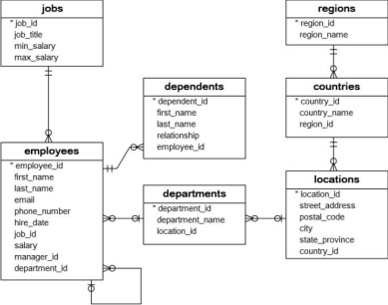

**CODE-RESULT:**

**1.** Retrieve the name of each dept and number of employees working ineach department which has at least 2 employees.

SELECT

department_name,

COUNT(*) AS 'no_of_employees'

FROM

employees

JOIN departments ON employees.department_id = departments.department_id GROUP BY

departments.department_id

HAVING

no_of_employees >= 2;

Result:

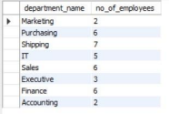

**2.** Display the empno, name and salaries for employees whose average salary is higher than the average salary of the organization.

SELECT

employee_id,

CONCAT(first_name, ' ', last_name) AS 'name',

salary

FROM

employees

WHERE

salary > (

SELECT

AVG(salary)

FROM

employees

);

Result:

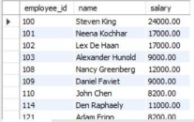

**3.** Display the details of employees whose salary is equal to the minimum salary of the organization.

SELECT

*

FROM

employees

WHERE

salary = (

SELECT

MIN(salary)

FROM

employees

);

Result:

**4.** Find the locations at which Employees are situated.

SELECT

CONCAT(first_name, ' ', last_name) AS 'name',

street_address,

city,

state_province

FROM

employees

JOIN departments ON employees.department_id = departments.department_id

JOIN locations ON departments.location_id = locations.location_id;

Result:

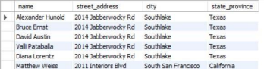

**5.** Display different kinds of job available.

SELECT

job_title

FROM

jobs;

Result:

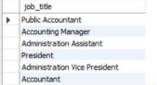

**6.** Display the name and the dept. numbers of the employees whose Jobs are ‘analyst’ or ‘clerk’ (analysts and clerks are just examples of the job titles. You can have your own job titles).

SELECT

CONCAT(first_name, ' ', last_name) AS 'name',

department_id

FROM

employees

JOIN jobs ON employees.job_id = jobs.job_id

WHERE

job_title IN ('Accounting Manager', 'Shipping Clerk');

Result:



**7.** Find out the difference between maximum salary in dept. 10 and minimum salary earned by a person in dept. 30 (dept.10 and dept. 30…examples. You have to use dept. number in your database).

SELECT

(

SELECT

MAX(salary)

FROM

employees

JOIN departments ON employees.department_id = departments.department_id WHERE

departments.department_id = 10

) - (

SELECT

MIN(salary)

FROM

employees

JOIN departments ON employees.department_id = departments.department_id WHERE

departments.department_id = 5

);

Result:

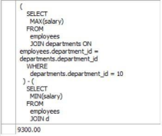

**8.** Find out the employees whose salary is < the average salary of dept. say 30 (dept. number 30).

SELECT

first_name,

last_name,

salary

FROM

employees

WHERE

salary < (

SELECT

AVG(salary)

FROM

employees

JOIN departments ON employees.department_id = departments.department_id WHERE

departments.department_id = 7

);

Result:

